EXPERIMENT NO. 1c

Aim: To design child monitoring app

Theory:

Now-a-days parents are getting too busy with their job schedules and tend to forget about the child and babies. After a facing a small accident by the child and later parents notice it, will not affect much as they couldn’t able to stop the accident. To overcome from this small mishap to the kids we have introduced child monitoring system. This app will help the parents to monitor the baby and look after.

Existing apps:

1. Netspark

(https://play.google.com/store/apps/details?id=com.playtic.monsternumbersFull&hl=en)

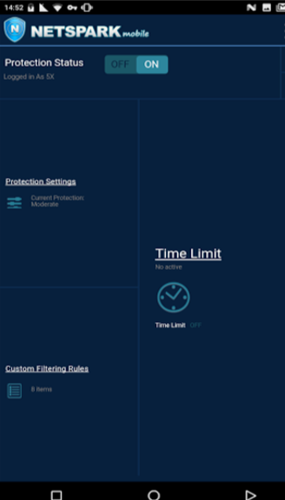

The above is the main landing dashboard page of the app and its not great. Suffers because of a lot of empty space and looks unorganised. It might take a while to get familiar with such interface.

1. Kidszone

(https://play.google.com/store/apps/details?id=com.ootpapps.kids.zone.app.lock)

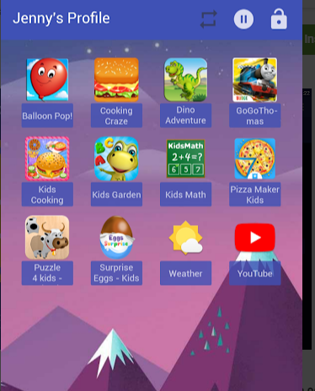

While the overall look and feel of the app is decent, one good element to be highlighted is that it uses app logo icons for app control page where most other app have checkboxes or radio buttons. It is a good idea. But the background and colors does not give a sophisticated feel.

1. Kaspersky safekids

(https://play.google.com/store/apps/details?id=com.kaspersky.safekids)

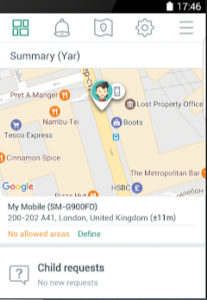

This app uses icons for navigation menu items. Well the targeted users i.e parents may not be so familiar and comfortable with icons. It is not a good option for the ui element.

Choice of screen elements:

The app contains the following screen elements:

* The screen background is colourful but does not strain the eye.
* Instructions and text are kept simple.
* Kid’s favourite desserts are used to represent items.

The app is better because

* The user interface is attractive and the colours used are pleasing to look at and do not strain the eyes where some of the other apps failed.
* The working is simple to understand and does not complicate things unnecessarily.

UI Design:

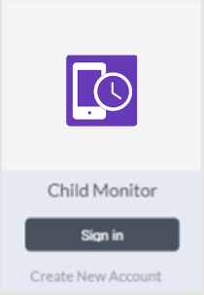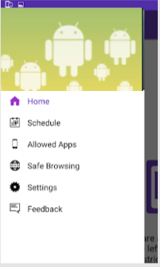

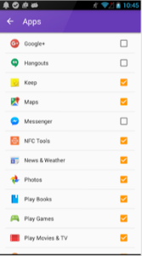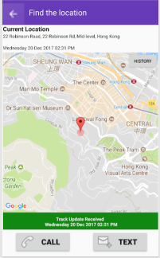

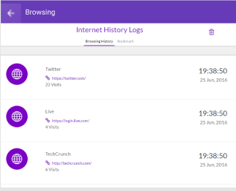

Conclusion:

This app would be of great use to working parents because of their busy schedule. Our app provides all the major features. The interface is very easy to get familiar with. Parents can monitor their child’s activites anytime, anywhere and thus can save time!